Using LockDown Browser and a Webcam for Online Exams
This course requires the use of LockDown Browser and a webcam for online exams. The webcam can be built into your computer or can be the type that plugs in with a USB cable. Watch this short video to get a basic understanding of LockDown Browser and the webcam feature.
When you start a quiz that requires Respondus LockDown Browser or Respondus Monitor, the quiz will require you to install Respondus LockDown Browser and will not let you take the quiz without it.
Acquiring Respondus LockDown Browser/Respondus Monitor Software
Any quiz requiring Respondus LockDown Browser or Respondus Monitor will provide a link to download the software from the quiz’s link in Canvas. If you would like to download the software now, click the following link:
http://www.respondus.com/lockdown/download.php?id=641414516
After installing the software, only quizzes requiring Respondus LockDown Browser or Respondus Monitor will appear in the Respondus test list.
To ensure LockDown Browser and the webcam are set up properly, before each test do the following:
- Start LockDown Browser, log into [INSTRUCTOR: ENTER LMS NAME HERE], and select this course.

- Locate and select the Help Center 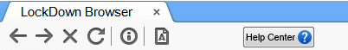 button on the LockDown Browser toolbar.
- Run the Webcam Check and, if necessary, resolve any issues.

- Run the System & Network Check. If a problem is not detected, click the Return to Course button.

- If a problem is detected, choose to Email Results by clicking on the respective button. Be sure to include your instructor’s email as a recipient of the email report. If no issues are found, click Return to Course.
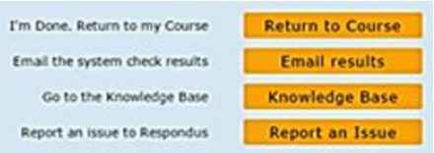

- Exit the Help Center and locate the practice quiz named [NOTE TO INSTRUCTOR: CREATE A BRIEF PRACTICE QUIZ AND INSERT NAME OF QUIZ HERE; IF NECESSARY, INCLUDE LOCATION OF QUIZ].
- Upon completing and submitting the practice quiz, exit LockDown Browser.

When taking an online exam that requires LockDown Browser and a webcam, remember the following guidelines:
- Ensure you're in a location where you won't be interrupted
- Turn off all other devices (e.g. tablets, phones, second computers)
- Clear your desk of all external materials not permitted — books, papers, other devices
- Remain at your computer for the duration of the test
- If the computer or networking environment is different than what was tested above, repeat the Webcam and System checks prior to starting the test
- To produce a good webcam video, do the following:
  - Avoid wearing baseball caps or hats with brims
  - Ensure your computer or tablet is on a firm surface (a desk or table) — not on your lap, a bed, or other surface that might move
  - If using a built-in webcam, avoid tilting the screen after the webcam setup is complete
  - Take the exam in a well-lit room and avoid backlighting, such as sitting with your back to a window
- Remember that LockDown Browser will prevent you from accessing other websites or applications; you will be unable to exit the test until all questions are completed and submitted.

